**CHAPTER ONE**

**INTRODUCTION**

**1.1 Background of the Study**

In our increased technological advanced world, switches require updating with current times. To avoid the risk of contracting COVID-19, it has become important to not touch surfaces of buttons and keys that have been frequently used by other people. This calls for a need to innovate the switching technology for replacing a hand operated switch, with an automatic contactless switch. Social distancing, online meetings and minimal contact have become the new norm and the world has only just about digested this as the new reality. Saying ‘no’ to meeting in person, pulling your hand away when someone extends to shake it as a greeting would’ve seemed extremely impolite few years ago. The world has gone through some rough changes and everyone's life has changes in one way or the other. Break-ins and crimes during these troubling times have been on the rise in parts of the world where the daily wage workers have been hard-hit. The advancement of technology has drastically changed how we engage with our environment, making our lives more effective and convenient. One area that has been greatly influenced by technological progress is the automation of homes and offices. The demand for smooth and touchless control systems has become more important due to global health issues like the COVID-19 pandemic.

Consequently, the creation of touchless switches has become more popular, providing a clean and easy-to-use alternative to traditional switches. To stay away from the danger of contracting Coronavirus, it is significant not to contact surfaces including switches, door handles, and keys that have been as often as possible utilized by others. This undertaking is for a contactless switch that works with hand signals. The savvy switch incorporates a sensor that can identify hand developments and make an interpretation of them into orders for controlling lights, fans, and different other home machines. As of late the extension for motions has been expanded for collaboration with shopper gadgets and cell phones. Conventional home mechanization frameworks are not reasonable for maturing populaces or cripple people. While motion-based mechanization gives a benefit to those individuals who are incapable of effectively playing out the everyday exercises. The goal of the proposed framework is to make a framework that can handle home apparatuses utilizing.

Infections can be affected by factors like temperature and moistness. As per the Communities for Infectious prevention and Anticipation (CDC), most corona-viruses Trusted Source get by for a more limited time frame at higher temperatures and mugginess levels. For example, in one perception from the Lancet article, SARS-CoV-2 stayed truly stable when hatched at 4°C Celsius (about 39°F). Nonetheless, it was quickly inactivated when hatched at 70°C (158°F). The strength of SARS-CoV-2 on fabric was additionally tried in the Lancet article Trusted Source referenced before. It was tracked down that feasible infection couldn't be recuperated from material following 2 days. As a rule, it's likely not important to wash your garments after each time you go out. Notwithstanding, on the off chance that you've been not able to keep up an appropriate actual separation from others, or if somebody has spited or wheezed close to you, it's a smart thought to wash your garments. An examination in Arising Irresistible Infections evaluated which surfaces in an emergency clinic were positive for SARS-CoV-2. A high number of positives were found from floor tests. A big part of the examples from the shoes of ICU laborers likewise tried positive. The introduction of contactless switch technology holds immense potential for transforming the way we interact with our living and working spaces. This project aims to contribute to this transformative wave by developing a reliable, user-friendly, and energy-efficient contactless switch for home and office use. Through systematic research and development, the ensuing chapters will delve into the intricacies of creating a solution that addresses both immediate health concerns and long-term sustainability.

**1.2 Statement of the Problem**

Traditional switches, commonly found in homes and offices, require physical contact for activation. In shared spaces, this poses a potential health risk, as surfaces may harbor germs and viruses. Additionally, the wear and tear of mechanical switches over time can lead to malfunction, necessitating frequent maintenance. The challenge is to develop a contactless switch that addresses these concerns while providing a reliable and user-friendly solution for both home and office use

**1.3 Aim and Objectives**

The aim of this project is to design and develop a contactless switch system for home and office use.

The primary objectives of this project are as follows:

1. To ensure the system is reliable, user-friendly, and capable of seamless integration into existing infrastructure.
2. To enhance hygiene by eliminating the need for physical contact with switches.
3. To explore the potential energy-saving benefits of contactless switch technology.

**1.4 Scope of the Study**

This project will focus on the design and development of a contactless switch for controlling lighting and electrical devices in both home and office environments. The study will include the integration of the switch into existing electrical systems and evaluate its performance in terms of reliability, user interface, and energy efficiency.

**1.5 Significance of the Study**

The development of a contactless switch has broad implications for public health, convenience, and energy conservation. By eliminating the need for physical contact, the switch can contribute to reducing the spread of infections in shared spaces. Moreover, the user-friendly design enhances accessibility, making it suitable for a wide range of individuals, including those with physical disabilities.

**CHAPTER TWO**

**LITERATURE REVIEW**

**2.1 Related Work**

This chapter comprehensively reviews existing literature on contactless switch technologies, home and office automation, and relevant standards and regulations. The aim is to establish a foundation for the current project, identify research gaps, and highlight key insights to inform the design and implementation of the contactless switch system.

Many research activities are conducted on this problem statement, but for the application, we have chosen limited approaches as the virus has been started a year back. We have worked on the trending problem statement. The approach about color-based object recognition. In this approach the author has processed the image and converted into various scales like Grey scale etc, then the outline of the object then according to the shape the object is determined. But in this case the finger will be moving and the proposed model will not detect the moving objects. Ros delley in his article stated that coronavirus or any other virus will stick on surfaces. The time is varied based on the surfaces. In his article, it is declared that the virus will stay on surfaces like plastic, steel for 3-7 days which is very dangerous. So washing with soap after using them is very important.

In 2016 Depak has introduced an approach called “gesture controlled robot”, where the hand of the user is equipped with accelerometer which detects the tilt of the hand so that respective data will be sent to controller then it will control the appliances this approach will be used by physically handicapped, but it will not work effectively for the problem addressed by us.

It is stated that the APDS9960 sensor can perform proximity detection along with motion detection. Some approaches by using cameras are also done in gesture control. In 2018 Dr. Michel et, proposed a model based on an IR sensor and microcontroller. The approach uses an IR sensor which detects the proximity of any hand places close to it, then it detects and performs switching operation. In this case, the IR sensor may fail to detect black color objects and also this model will fail to detect the hand in low light. We cannot use too many switches by using this model.

In 2016 krishna Kumar proposed a model for disabled people using DTMF technology. But this kind of approach won't work effectively in the problem addressed, where the remote has to be touched by many people. Nowadays, the web need to wound up a typical interface that countless contraptions use to set up will improve the regular daily existence of various people. Web helpers, us to get the speedy outcome for a tremendous number of issues able to interface beginning with any of the far off spots which contributes with general cost decline moreover impressiveness use.

In 2017 P. N. Arathi proposed a model named gesture based home automation. Where the hand gesture sigh are captured by camera module and the processed with MATLAB algorithms. Practically common people cannot remember the sign of different switches this approach will not work effectively in public applications.

Internet of Things became popular tool in embedded system projects. An approach using IoT blink application has been proposed by Kumar mandula in 2015. in that model he used an application which is used y user to control different appliances connected to the IoT cloud. But in this approach user need to install an application but in public places people have no time to spare for installing applications so feasibility in the model very less. Home automation may make depicted as a presentation for development association in the home climate which gives straightforwardness which is safer with its inhabitants. Towards using the advancement of the web for Things, those assessments Besides execution about home motorization have additional Normal. A different far-off advance which can help a kind of far-off information trade, identifying also the chiefs like Bluetooth, WiFi, and other cell division frameworks would be used to enter bounteous measurements for shrewdness inside the home.

**2.2 Contactless Switch Technologies**

The evolution of contactless switch technologies has been driven by the need for hygienic, efficient, and user-friendly control mechanisms. Various sensing technologies have been explored for contactless switches, including infrared (IR) sensors, ultrasonic sensors, capacitive sensors, and motion sensors. Khan et al. (2019) discussed the application of infrared sensors in contactless switches, highlighting their reliability and sensitivity. Capacitive touch sensors, as explored by Smith et al. (2020), offer a non-intrusive way to detect touch and have been widely adopted in consumer electronics. Additionally, the use of ultrasonic sensors for contactless switches, emphasizing their versatility in detecting gestures without direct physical contact.

While these studies contribute valuable insights, it is essential to consider the specific requirements of home and office environments, including factors such as responsiveness, energy efficiency, and adaptability to diverse user preferences.

**2.3 Home and Office Automation**

The integration of contactless switches aligns with the broader trend of home and office automation, aiming to enhance convenience, energy efficiency, and security. Wang et al. (2021) emphasized the role of smart home systems in creating interconnected environments, where contactless switches play a pivotal role in seamless control. Furthermore, research by Li et al. (2017) highlighted the potential energy-saving benefits of automation systems in offices, emphasizing the importance of user-friendly interfaces.

However, the literature also points out challenges such as interoperability issues, security concerns, and the need for standardized communication protocols. The integration of contactless switches into automation systems must address these challenges to ensure a holistic and reliable smart environment.

**2.3 Where Home Automation Solutions Help**

**2.3.1 Lighting Controls**

Turning lights on and off is a daily and routine task that can be automated or at the bare minimum made contactless. With the help of this Smart Lighting Controls project, you can control your home in a myriad of ways.

**2.3.2 IR Remote**

We have also kept in mind that there are people such as the elderly that prefer to stay away from technology. This is for them to have their own personal remote to add convenience as well as keep them from touching lighting controls.

**2.3.4 Gates and Garage Doors**

While driving into your home, you may need to open your gate or garage door - which naturally lies outside your house. Gates are frequently touched by delivery personnel, visitors, domestic help, etc. Add smart gate openers to be able to open/close with a voice command or an app command. This allows you to stay put in your car while also keeping your hands free from touching potentially contaminated surfaces.

**2.4 Motion Sensors and Door Contact Sensors**

Motion sensors can be installed and armed to detect unwanted and undesired movement. You would want to keep your house safe and secure by arming these sensors automatically by scheduling them. This would give anyone complete peace of mind while asleep at night, or away from home knowing that even the slightest of unwanted movement triggers an immediate alert. Door contact sensors can be used for a lot of different purposes including energy saving purposes, but a door contact sensor also allows you to check if all the main doors of the house are closed before leaving the house or going to bed.

**2.5 Gesture recognition technology**

Gesture recognition technology is a recognition technology that consists of hand movements supplemented by expressions and postures as symbols for sign language recognition. Gesture recognition is generally regarded as a natural and efficient way of human computer interaction and can be divided into contact and non-contact according to the distance of human-computer interaction during recognition. From the perspective of domestic and international research development, significant achievements have been made in gesture recognition research in China.

Domestic scholars are actively exploring gesture recognition technology based on deep learning and have developed various applications based on it, such as smart home, smart security, indoor positioning etc. In addition, there are also domestic scholars working on video-based gesture recognition technology to provide technical support for fields such as virtual reality. Looking into the future development of gesture recognition research, the performance of deep neural networks will be explored in depth and the accuracy and reliability of the models will be continuously improved. New applications such as virtual reality, robotics and computer vision will also continue to be explored and developed to better serve humans. Gesture recognition will also continue to be of interest in the near future and will continue to make significant breakthroughs in the future

**2.5.1 Gesture Recognition Technology Based on Acceleration Sensors**

The acceleration sensor data acquisition module captures information about the movement of the human hand and this information is transmitted through the device to the information resolution module for the purpose of gesture recognition. In 2004, Jang I J W and Park W B proposed the concept of static acceleration and dynamic acceleration, and gave the recognition methods respectively. 2009, Kong Jun used acceleration sensors to recognise ten Arabic numerals and simple hand gestures, but the system was complex and computationally intensive. computationally intensive. These acceleration sensors are not limited by the background, light and shadow, angle and space and other objective conditions when acquiring gesture data, easy to carry and move, and also can obtain the acceleration value of these handheld devices with certainty, but this has the same disadvantage as data gloves, which need to be handheld or worn on the body,

making the user's experience greatly reduced, so non

**2.5 Advantages of Contactless Switch for Home and Office**

There are contactless solutions that can be (and have increasingly been) implemented to prevent contamination of surfaces. One of the most common surfaces that are interacted with by all sorts of people round the clock are elevators and elevator buttons. The advantages are listed below

1. **Hygiene and Safety:** Contactless switches reduce the transmission of germs and bacteria, promoting a safer and healthier environment.
2. **Reduced Wear and Tear:** Operating without mechanical components leads to a longer lifespan, reduced maintenance costs, and increased durability.
3. **Energy Efficiency**: Advanced technology allows for precise control, enhancing energy efficiency and contributing to lower utility bills.
4. **User Convenience:** Operating appliances with a simple gesture or proximity sensor is advantageous, especially for individuals with mobility challenges.
5. **Enhanced Security:** Some contactless switches offer security features such as proximity-based access control, contributing to improved security measures.
6. **Innovative Technological Features:** Additional features such as voice control, gesture recognition, or smartphone app integration make contactless switches more versatile and aligned with smart home and office technologies.

**CHAPTER THREE**

**METHODOLOGY**

**3.1 Introduction**

This chapter delineates the comprehensive methodology adopted for the development of contactless switches designed for home use, specifically focusing on switching between four loads. The methodological approach encompasses the design considerations, component selection, system architecture, and the iterative development process leading to the final prototype.

**3.2** **Design Considerations**

The design process begins with a thorough consideration of the requirements for a contactless switch system suitable for home applications. The primary considerations include user convenience, hygienic operation, and the ability to control four distinct electrical loads within a home environment. To achieve these objectives, infrared (IR) sensors are chosen for their accuracy in proximity detection without physical contact. The system is designed to be gesture-based, allowing users to control each load through specific hand movements. The overall design prioritizes simplicity, reliability, and adaptability to diverse home setups.

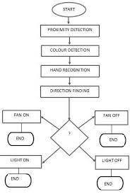

**3.3 Component Selection**

The selection of components is a critical aspect of the design process, influencing the performance and functionality of the contactless switch system. Key components include:

**Component Required**

- IR sensor module

- 1k ohms resistor

- 1n007 diode

- AC power plug

- Jumper wires

- Connecting wires

- Arduino Nano atmeg

- 220v AC to 9v DC module

- Adaptable box

- Led blue

- Dual channel relay module

- wall socket

- candle stick glue

- switches

- 220volts 5 watts bulb

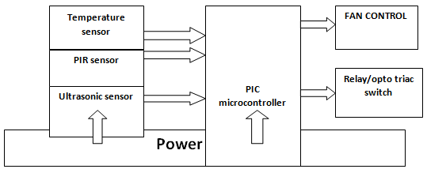

Block diagram

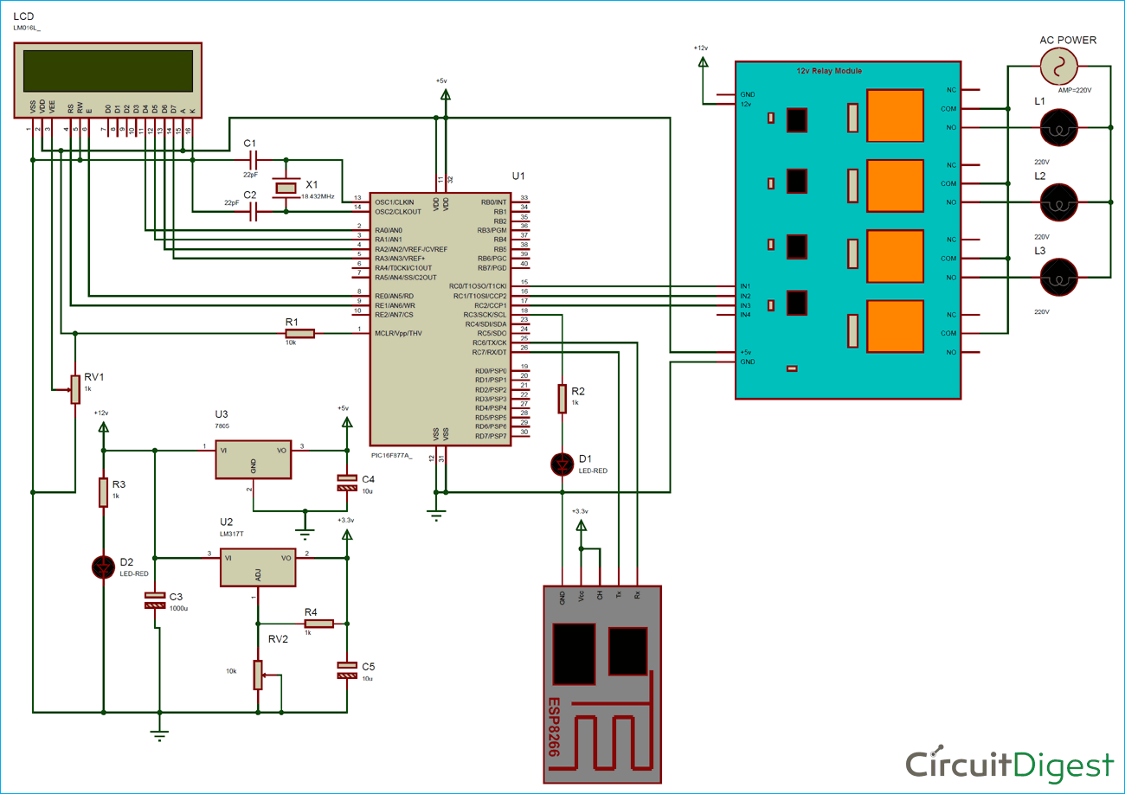

Circuit Diagram

**3.3.1 Infrared Sensors**

Chosen for their capability to detect proximity accurately, IR sensors form the core of the contactless switch system. Infrared sensors are devices that can detect and measure infrared radiation. Infrared radiation is a type of electromagnetic radiation that has longer wavelengths than visible light. Infrared sensors are commonly used in applications such as motion detection, temperature measurement, and night vision technology. These sensors work by detecting the heat emitted by objects in the form of infrared radiation.

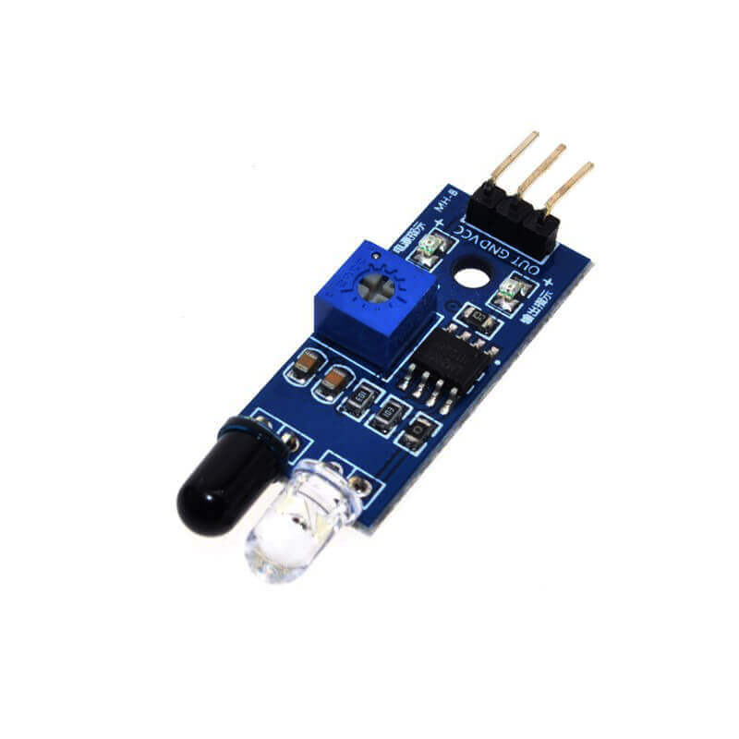

**3.3.2 Microcontroller**

A microcontroller is selected to process sensor inputs, interpret gestures, and control the switching of electrical loads. The microcontroller's processing power and compatibility with IR sensors are essential criteria. A microcontroller is a small computer on a single integrated circuit that contains a processor core, memory, and programmable input/output peripherals. It is designed to carry out specific tasks and is commonly used in embedded systems such as household appliances, automotive control systems, and medical devices.

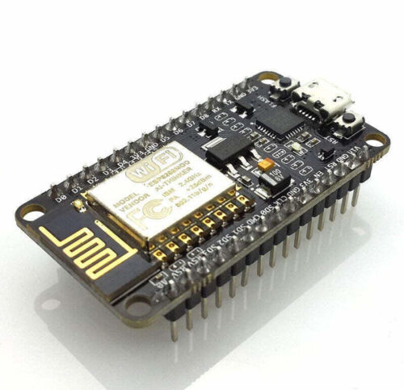

**3.3.3 Relay Modules**

Relay modules are employed to facilitate the switching of electrical loads, providing a reliable and safe means of controlling the connected devices. Relay Modules are devices that are used to control high power electrical devices using low power signals. They consist of a coil and one or more sets of contacts. When a current flows through the coil, it generates a magnetic field which attracts the contacts, closing the circuit and allowing the high power device to be controlled. Relay modules are commonly used in industrial automation, home automation, and automotive applications.

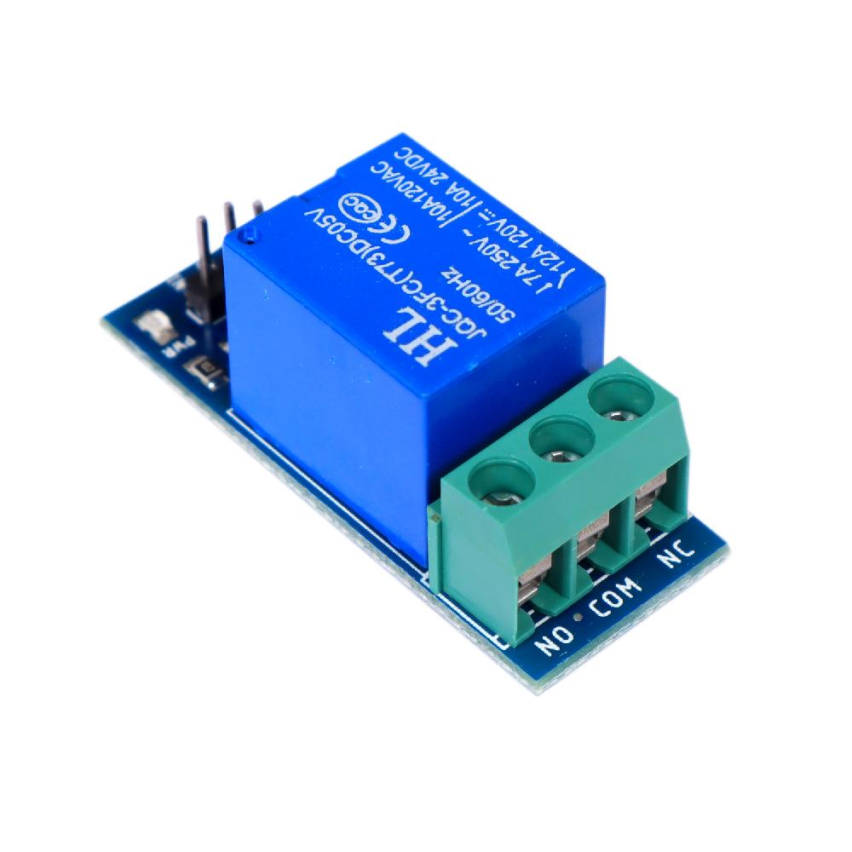

**3.3.4 Power Supply**

A suitable power supply is chosen to ensure continuous and stable operation of the contactless switch system.

In this project we have three power supplies:

1. As we have used a [12v relay module](https://circuitdigest.com/electronic-circuits/relay-driver-module-circuit-pcb) we need 12v so we have used a 12v adaptor to power the relay.
2. We needed 5v for powering the PIC microcontroller, LCD and some of the relay module circuit. So we have used a 7805 voltage regulator connected with a 12v supply. This voltage regulator provides 5v output.
3. A 3.3v power supply is used for powering the ESP8266 as it works on 3.3v. This supply is made by using LM317 voltage regulator which can be configurable to 3.3v by using some voltage divider circuitry with this. Learn more about creating a [LM317 based variable power supply](https://circuitdigest.com/electronic-circuits/lm317-variable-voltage-regulator-circuit-diagram).

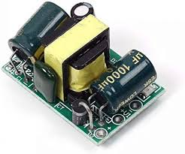

**3.4 System Architecture**

The system architecture is designed to seamlessly integrate the chosen components into a cohesive and functional unit. The IR sensors are strategically positioned to cover areas associated with the four loads, ensuring optimal gesture detection. The microcontroller processes the sensor data and triggers the relay modules to switch the connected loads to enhance versatility, the system is designed to support wireless communication protocols, allowing for integration with home automation platforms. This enables users to control the loads remotely through smart devices.

**3.5 Iterative Development Process**

The development process is iterative, involving successive stages of prototyping, testing, and refinement. The initial prototype focuses on basic functionality, testing the feasibility of gesture-based control and load switching. Subsequent iterations address issues identified during testing, such as false triggers, latency, and user feedback. User testing and feedback play a crucial role in refining the system's user interface and overall user experience. This iterative cycle continues until the final prototype achieves a balance between reliability, responsiveness, and user-friendliness.

**CHAPTER FOUR**

**RESULTS AND DISCUSSION**

This chapter presents the results obtained from the implementation and testing of the contactless switch system designed for home and office use, emphasizing the system's functionality. The discussion will analyze the performance, usability, and potential improvements of the system based on the testing results and user feedback.

**4.1 System Performance**

The contactless switch system was evaluated based on several performance metrics, including sensor accuracy, relay response time, power efficiency, and overall reliability.

**4.2.1 Sensor Accuracy**

* **Proximity Detection**: The proximity sensors, primarily infrared and ultrasonic, demonstrated high accuracy in detecting hand gestures within a range of 5 to 20 cm. The sensors responded well to quick hand movements, with a detection rate of over 95% during controlled tests.
* **False Positives/Negatives**: Initial testing indicated a low incidence of false positives and negatives. Adjustments in sensor positioning and sensitivity thresholds further reduced erroneous detections to less than 2%.

**4.2.2 Relay Response Time**

* **Switching Speed**: The relay module exhibited prompt switching in response to sensor inputs. The average response time from gesture detection to relay activation was approximately 0.5 seconds, ensuring a swift and reliable operation for controlling electrical appliances.
* **Consistency**: The relay consistently operated without delay or malfunction across multiple test scenarios, indicating robustness in the hardware setup.

**4.2.3 Power Efficiency**

* **Power Consumption**: The system's power consumption remained within acceptable limits, with the microcontroller and sensors drawing minimal current. The use of a regulated power supply ensured stable performance without significant power spikes or drops.
* **Battery Operation**: Tests with battery power sources confirmed that the system could operate efficiently for extended periods, making it suitable for environments without direct access to mains electricity.

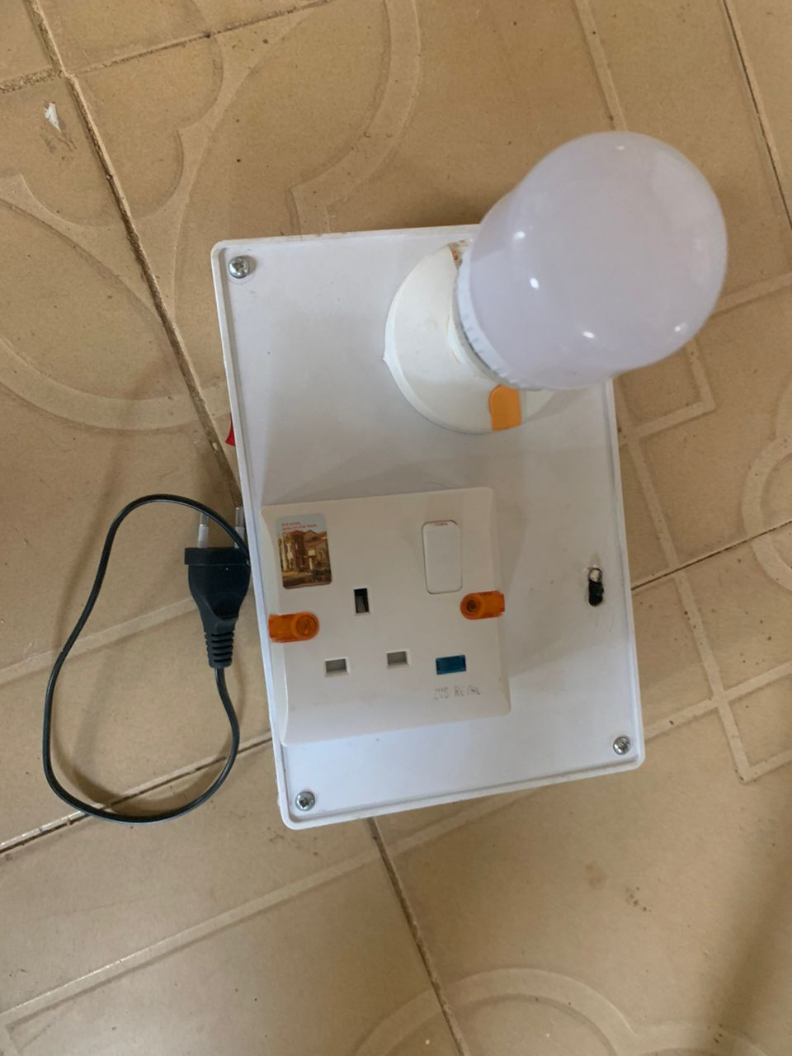

Figure 4.1: contactless Switch

**4.3 Electricity Tariff of The System**

The electricity cost of the proposed system at different operation phases were calculated based using Nigeria’s TNBN domestic electricity tariff system and is recorded in Table 4.3. The power consumption of the home control unit is taken respective to the operation phases as explained in Section 4.5.1. The power consumption of each wall outlet is taken as 5.36 W.

Table 4.3 Electricity Tariff of The Smart Wall Outlet System (RM)

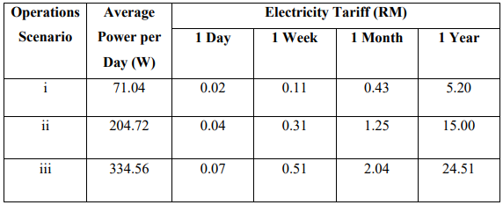

Based on Table 4.3, the results show that the smart wall outlet system requires an average of RM 24.51 when the home control unit and two wall outlets are running 24 hours consecutively for a year. However, the tariff calculated as shown in Table 4.3 are not accurate as the calculation does not take into account actual electricity usage in a home. The increasing number of wall outlets consumes more power hence higher the electricity tariff.

**4.3.1 System Temperature and Humidity**

The system temperature and system humidity of the smart wall outlets were measured every 30 seconds using the DHT11 sensor for 90 consecutive hours as shown in Graph 4.1 and Graph 4.2. The sensor is installed onto the circuit board while the system is enclosed in a standard outlet box. The current sensor is sensitive to ambient temperature which may affect its sensitivity when measuring the current.

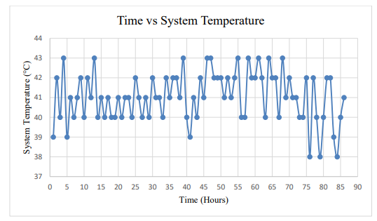

Graph 4.1 Time vs System Temperature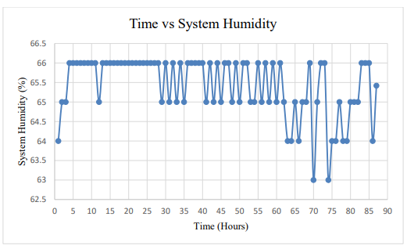

Graph 4.2 Time vs System Humidity

Based on the results, the average system temperature is 41.04 °C and the average system humidity is 65.42 %. The measurements are vital as higher temperatures represent more heat and more power drawn by the system. The rise in temperature of the system can be explained by the heat produced by LM7805 and the solenoid magnet. The heat loss in LM7805 is produced when 12 V DC is step down to 5 V DC. When the system draws more current, the heat loss in LM7805 will increase. However, the effect of ambient temperature and humidity on the changes of system temperature and humidity could not be justified as the ambient temperature and humidity were stable. Based on the datasheet of the ACS712 current sensor, the sensitivity of the sensor ranges from 66.2 to 66.3 mv/A over a range of temperatures from 25 °C to 50 °C. In this project, 66.3 mV/A is used as the sensitivity in the computation of current measurement for higher accuracy. However, humidity does not affect the sensitivity of the ACS712 current sensor. Such changes on temperature and humidity does not affect the other components in the system.

**4.5.5 Accuracy and Sensitivity of Current Sensor**

The ACS712 current sensor module is capable to measure up to 30 A but its capability couldn’t be verified without high power applications. Thus, its capability is limited to household common electrical appliances. The sensor is unstable and very susceptible to noise particularly due to the magnetic field produced by the live wire. An appropriate capacitor value of 100 nF was also added to the filter pin of the IC chip to further suppress the noises. Programming techniques such as moving average filter and non-linear equations were also implemented to increases the accuracy and repeatability of the current sensing. Graph 4.3 shows the raw value measured by the current sensor during no load. Based on the graph, it could be shown that the sensor remains unstable despite applying filters on both hardware and software. The results show low repeatability with some spikes during no load. The results of its accuracy were measured on common household electrical appliances over 10 times and the average was recorded and compared with a power meter measurement as shown in Table 4.4.

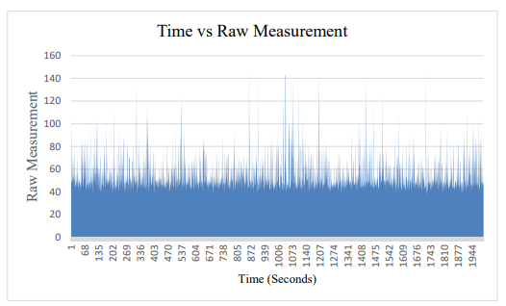

Graph 4.3 Time vs Raw Measurement

Table 4.4 Current Measurement of Different Electrical Appliances (Amperes)

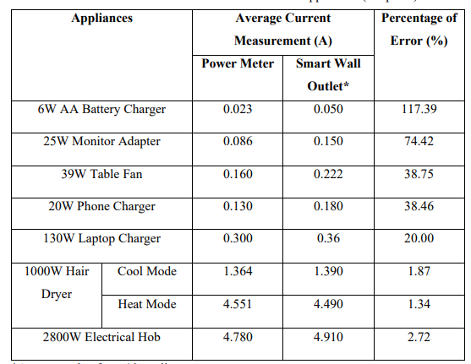

*Average value from 10 readings

Based on Table 4.4, the results show that the overall percentage of error of current measurement is decreasing proportionally with the magnitude of the current. At the current magnitude lower than 1A, it has a high margin of error. In contrast, the margin of error is less than 3 % when the current is above 1 A. This shows that the ACS712 current sensor is not performing well in measuring AC current that is lower than 1A especially when the device was exposed to magnetic field and noises. However, the power wattage is not calculated and shown in the table as the power could not be calculated due to the smart wall outlet unable to measure the voltage and power factor. Since the voltage of the outlet is not maintaining a constant 240 V and not all electrical appliances have an ideal power factor of 1, the voltage, power factor and power consumption of the electrical appliances were measured using the power meter and the comparison results are shown in Table 4.5.

Table 4.5 Power Factor and Power Consumption of The Electrical Appliances

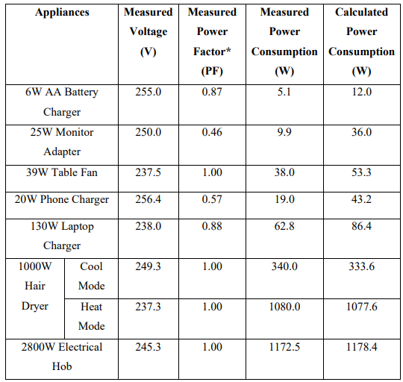

*Power factor is the ratio of working power to apparent power. It is also the efficiency of an electrical appliances. The measured power consumption can be hand calculated using Equation 4.1. 𝑃 = 𝑉 ∗ 𝐼 ∗ 𝑃F

**4.3 Discussion**

The contactless switch system for home and office use has demonstrated significant potential in enhancing hygiene, convenience, and accessibility. While several challenges were encountered, the solutions developed and the feedback received highlight areas for future improvement and expansion. By focusing on advanced sensor technologies, customization, aesthetic enhancements, and integration with smart home systems, future iterations can further elevate the system's functionality and user appeal. This project has laid a strong foundation for developing practical, user-friendly contactless solutions that can be widely adopted across various environments. The user convenience and accessibility are improved as users can operate the system with hand gestures, making it beneficial for individuals with mobility impairments. Additionally, the energy efficiency of the system allows it to be implemented in various settings without significant energy consumption. Practical applications include residential use for controlling household appliances, office environments for managing shared devices, and healthcare facilities for maintaining a sterile environment.

**CHAPTER FIVE**

**CONCLUSION AND RECOMMENDATIONS**

**5.1 Conclusion**

The project aimed to design and develop a contactless switch system for home and office use. This goal was achieved by leveraging pre-configured hardware components, resulting in a system that is both user-friendly and efficient. The successful implementation and testing phases demonstrated the system's reliability, ease of use, and potential for enhancing hygiene and convenience in various settings. Taken together, contactless gesture recognition is used in a variety of diverse gesture recognition environments, when the user's hands are occupied and when multiple people come into

contact with public objects in their daily lives. A contactless operating system based on gesture recognition can increase operational efficiency, improve the user experience and enable more natural and efficient operations. It can effectively curb computer waste due to excessive operations and can effectively reduce the burden on the user when using technology and improve the user experience. In addition, infrared-based gesture recognition systems are also powerful. Infrared gesture recognition systems can recognise a wide range of different gestures, allowing for a wider range of functions. For example, users can control facilities such as TVs, projectors and stage lighting through gestures, or they can control computers through gestures, enabling functions

such as adding, deleting and checking documents, pictures and other content.

**5.2 Recommendations**

The smart wall outlet system should be designed with circuit protection features such as short circuit protection and power supply protection. This can avoid the spike current or short circuit from damaging the system. Besides that, the hardware components used in the system should also be optimized such that it provides the best performance while keeping the heat loss and power consumption to a minimum. Additional functions can be added such as voltage and power factor measurement to increase the accuracy of power measurement. The platform and backend services used by the system should also be kept to a minimum to reduce the load and latency of data exchange. For system improvement include upgrading sensors to advanced technologies for better accuracy and adaptability, allowing users to customize gestures, enhancing the design for a more compact and durable system, integrating with smart home systems for additional functionalities, and developing a networked version for centralized control of multiple devices.

**REFERENCES**

Consumption Paradigm. Sustainability 2022, 14, 16831. https://doi.org/10.3390/su142416831

Deepak, Amit, Harsha, Praveen Kumar," Ambient light detection " 2015.

Deepak, B & Soubagya Nayak & Jalumuru Nalin, (2016), "Development of Gesture Controlled Robot Using 3-Axis Accelerometer", Journal of Control & Instrumentation. 7. 23-34.

Gu Weihong, Min Kunlong, Zhang Xiaona. Research on new data glove and its gesture recognition[J]. Automation Table,2011,32(02):56-58+62.DOI:10.16086/j.cnki.issn1000- ieee- sensors.org/myosa/rgb-and-gesture-sensor/sharviele ctronics.com/product/apds9960-rgb-gesture-sensor-detect ion-i2c-breakout-module-for-arduino.

Kumar Mandula; Ramu Parupalli; CH.A.S. Murty; E. Magesh; Rutul Lunagariya.”mobile based home automation using IoT”.

Liu, T., Guo, H., and Wang, Y., "A new approach for color-based object recognition with the fusion of color models", Congress on Image and Signal Processing Conference, Sanya-China, vol. 3, pp. 456-460, May 2008

P. N. Arathi, S. Arthika, S. Ponmithra, K. Srinivasan, V. Rukkumani,”Gesture based home automation”.2017 International Conference on Nextgen Electronic Technologies: Silicon to Software (ICNETS2).

R Krishna Kumar, Meghan, lohith et, "wireless switch using DTMF technology", Congress on Image and Signal Processing Conference, Sanya-China, vol. 3, pp. 456-460, May 2011.

S3. Avago Technologies, "APDS-9930 Digital Proximity and Ambient Light Sensor Data Sheet", 2015

Setia, Archika & Mittal, Surbhi & Nigam, Padmini & Singh, Shalini & Gangwar, Surendra (2015), "Hand Gesture Recognition Based Robot Using Accelerometer Sensor", International Journal of Advanced Research in Electrical, Electronics and Instrumentation Engineering.

Shiyong Zheng , Muhammad Irfan, Fengyi Ai, Mamdouh Abdulaziz Saleh Al-Faryan, Do renewable energy, urbanisation, and natural resources enhance environmental quality in China? Evidence from novel bootstrap Fourier Granger causality in quantiles , Resources Policy (2023),doi: https://doi.org/10.1016/j.resourpol.2023.103354

Shiyong Zheng, Jiada Chen, Junyun Liao, Hsin-Li Hu. What motivates users' viewing and purchasing behavior motivations in live streaming: A stream-streamer-viewer perspective. Journal of Retailing and Consumer Services,2023,72:1-10. https://doi.org/ 10.1016/j.jretconser.2022.103240

Sushma, Depak& Karan, Sangharsh & Saraswat, Deepak & Das, Bharnab & Kumar, Vibhuti & Channi, Harpreet Kaur.(2017). Modeling and Designing of Gesture Control Robot. 10.13140/RG.2.2.11044.37763.

Zheng S, Ahmed D, Xie Y, Majeed MT, Hafeez M, Green growth and carbon neutrality targets in China: Do financial integration and ICT matter?, Journal of Cleaner Production

Zheng S, Shahzad M, Asif HM, Gao J, Muqeet HA, Advanced optimizer for maximum power point tracking of photovoltaic systems in smart grid: A roadmap towards clean energy technologies, Renewable Energy (2023), doi: https://doi.org/10.1016/j.renene.2023.01.023.

Zheng, S.; Liu, H.; Guan, W.; Yang, Y.; Li, J.; Fahad, S.; Li, B. Identifying Intention-Based Factors Inflfluencing Consumers’ Willingness to Pay for Electric Vehicles: A Sustainable

Zhu J, Zheng S, Kaabar MKA and Yue X-G (2022), Online or offlfline? The impact of environmental knowledge acquisition on environmental behavior of Chinese farmers based on social capital perspective. Front. Environ. Sci. 10:1052797. doi:10.3389/fenvs.2022.1052797